How to make DMC plugin
Visual Studio C# is needed to create plugin for DMC.
- Run Visual Studio and create new Project.
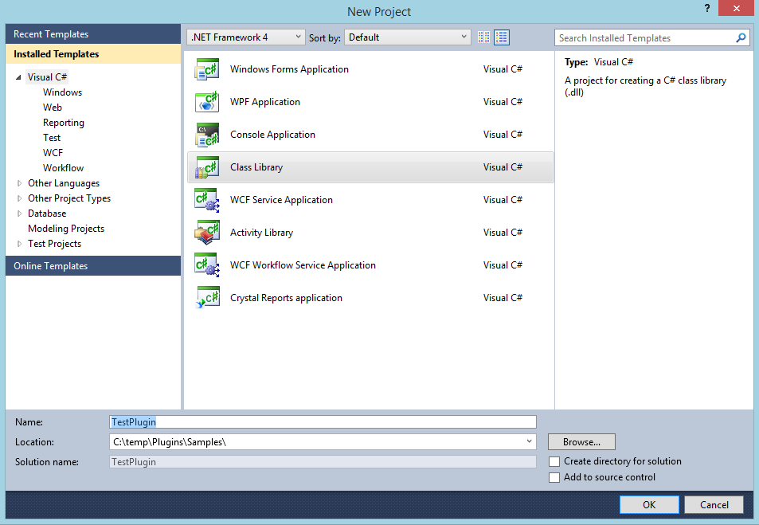
- Select project type “Class Library”
- Define project name. Project name must contain word “Plugin”. Only dll files with name containing word “Plugin” will be loaded.
- Select location where to save project

- Add references to created project.

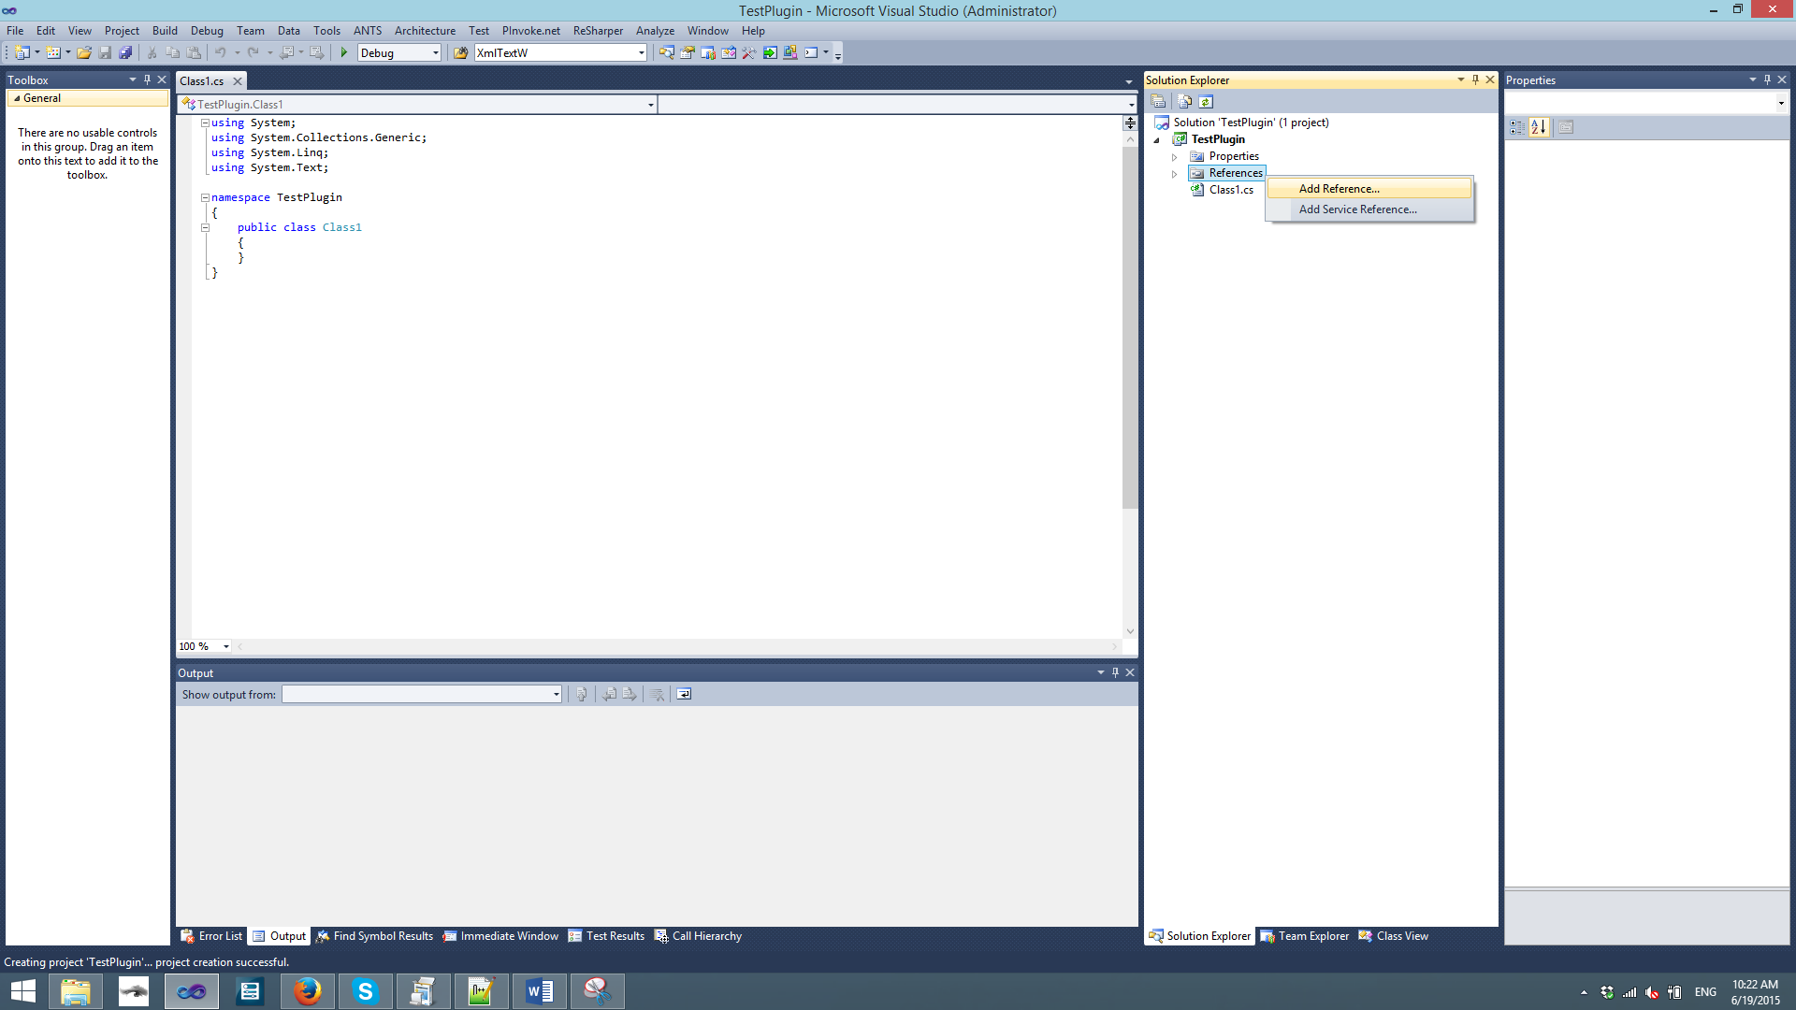

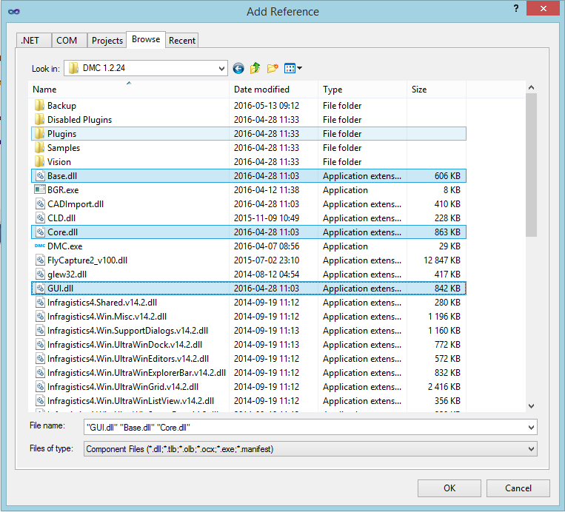
- Base.dll. Contains settings, interfaces (IAxis, , communicates with hardware, states.
- Core.dll. Contains interfaces of commands, commands (Line, Arc, ... ).
- GUI.dll. Contains top level functions that are used in main DMC window (Connect to hardware, Compile, Run, Stop, ... ), also has methods for adding/hiding custom buttons. .

- Select added references and set Copy Local to False.
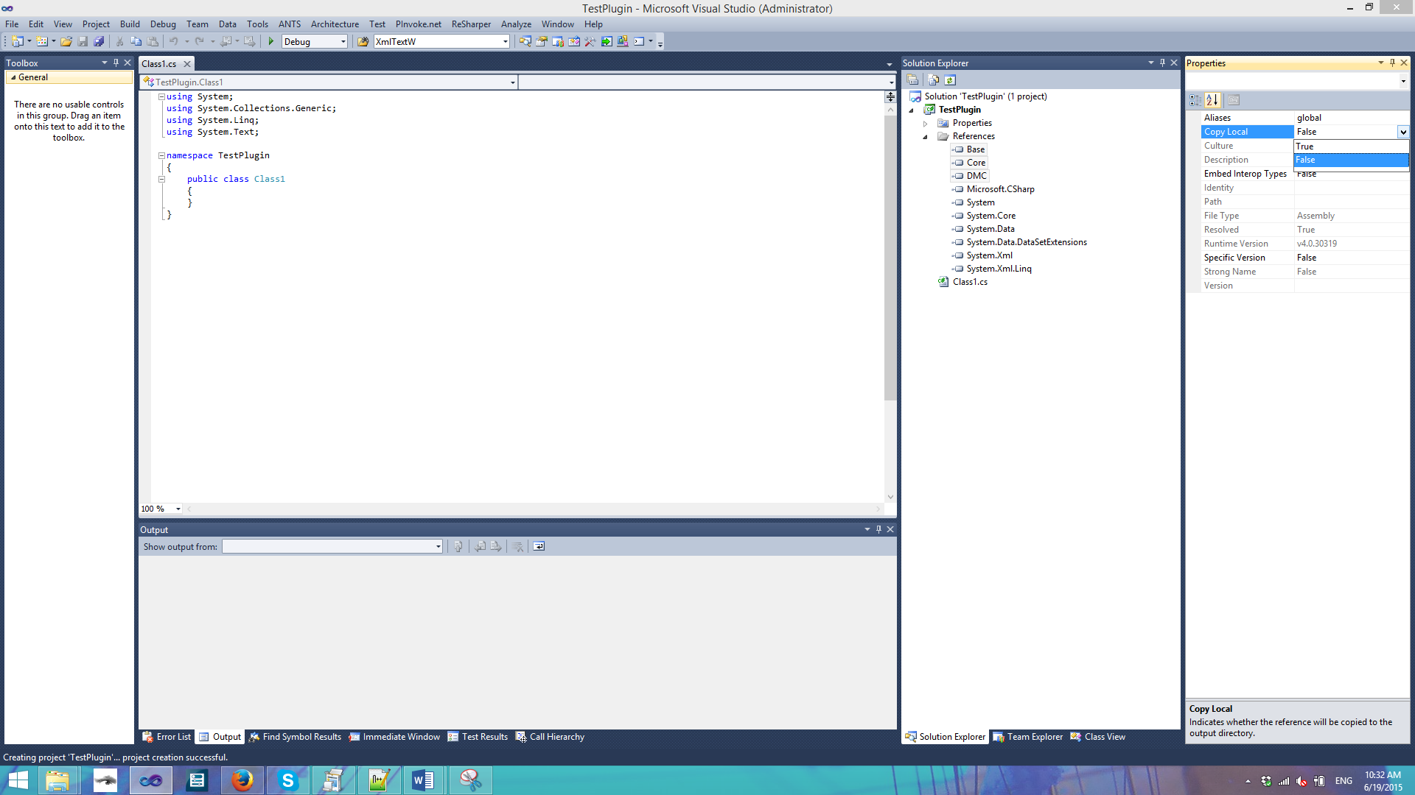

- Go to Project settings and change project “Output path” to DMC path + Plugin directory. E.g C:\Program Files\DMC\DMC 1.1.9\Plugins\
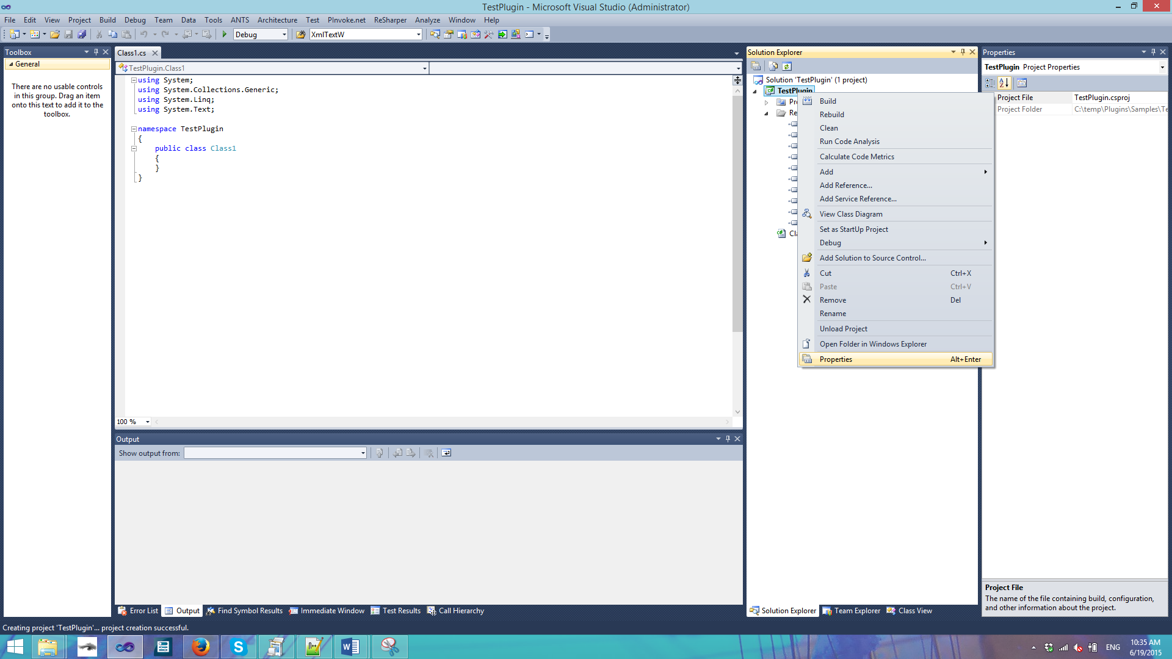
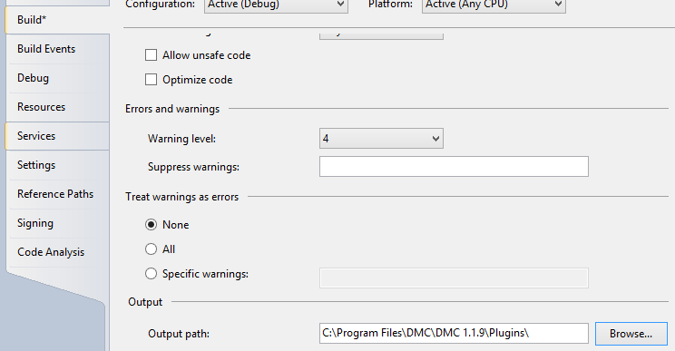

- Add DMC.exe to solution. Right click on solution, click Add->Existing project and browse for DMC.exe.
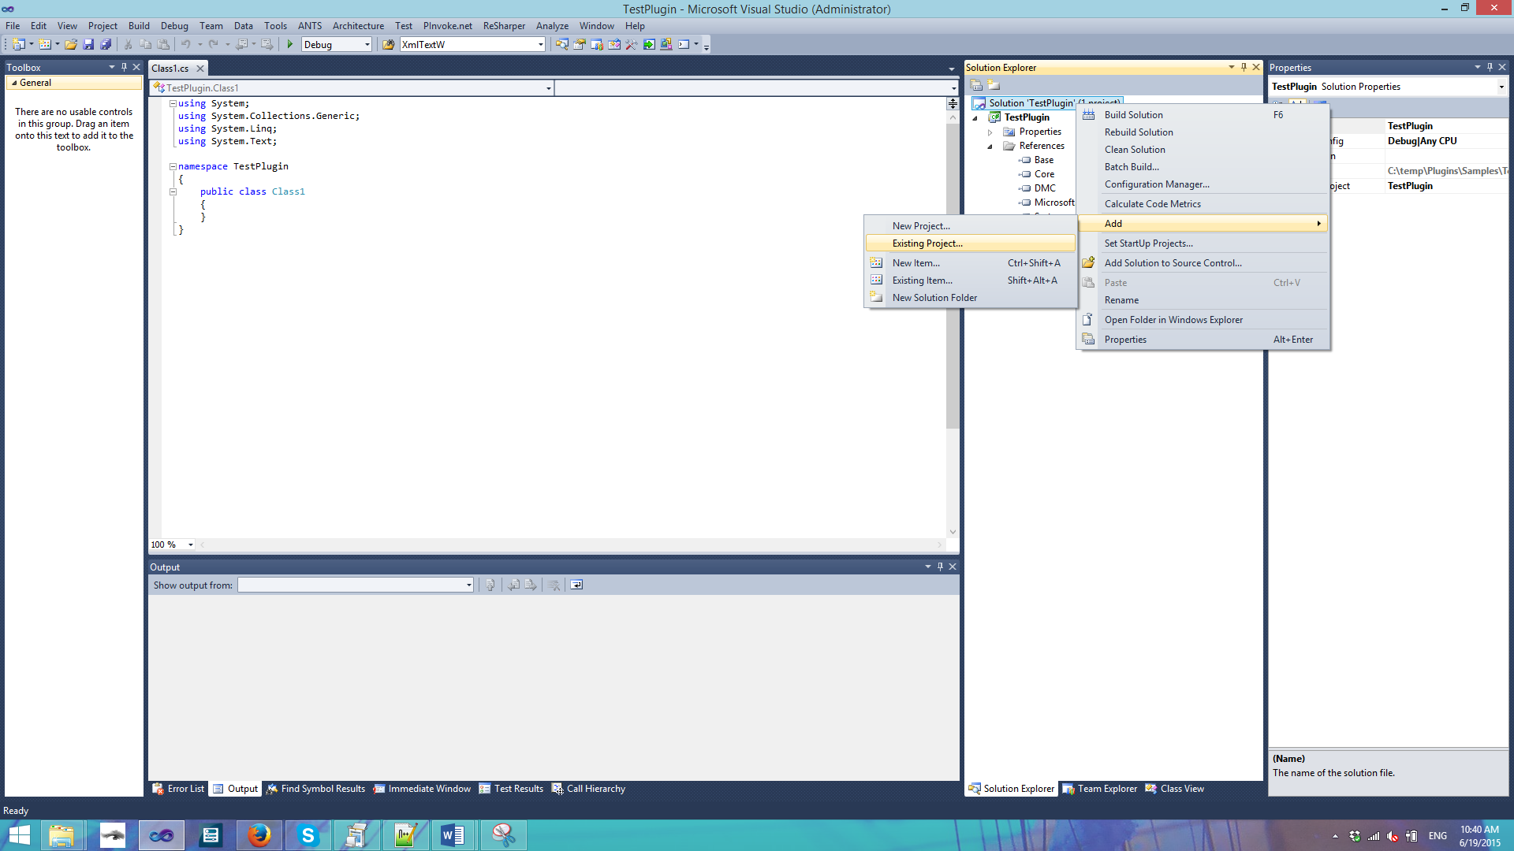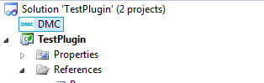

- Set DMC as StartUp Project
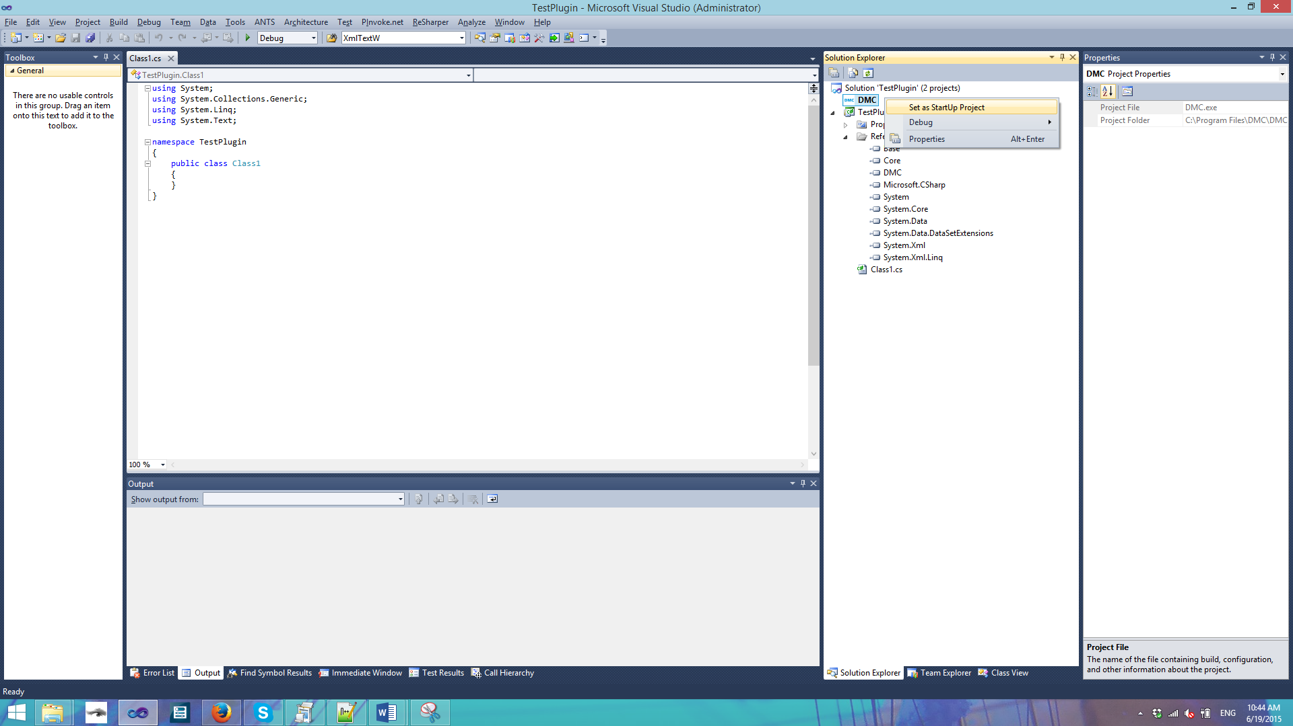

- Add Reference System.Windows.Forms and make code:
using System;
using System.Collections.Generic;
using System.Linq;
using System.Text;
using Base;

namespace TestPlugin
{
// Class name must be public, contain Plugin word, must inherit IDevice interface, can't be abstract
public class MyPlugin : IDevice
{
public MyPlugin()
{
// Change DMC main form title
DMC.Form1.main.Text += " with my plugin";
}

// Action when user clicks Connect to hardware and IsEnabled is true
public bool Connect() { return true; }

// Action when user clicks Disconnect from hardware
public void Disconnect() { }

// Action when user clicks Stop button
public void Stop() { }

public string GetName() { return "My Plugin"; }

// Action when changes to settings are confirmed or loaded during DMC startup
public bool ApplySettings() { return true; }

// Needs to return if device is connected
public bool IsConnected() { return false; }

// Is device is enabled
public bool IsEnabled() { return false; }

// Called before starting recipe
public bool OnRecipeStart() { return true; }

// Called after recipe is finished or stopped
public void OnRecipeFinish() { }

// Get device settings
public IDeviceSettings GetSettings() { return null; }

// Get error message ( is called if Connect returns false )
public string GetErrorMessage() { return Base.Functions.GetLastErrorMessage(); }
}
}

- For debugging purpose add breakpoint.

- Click Run. 